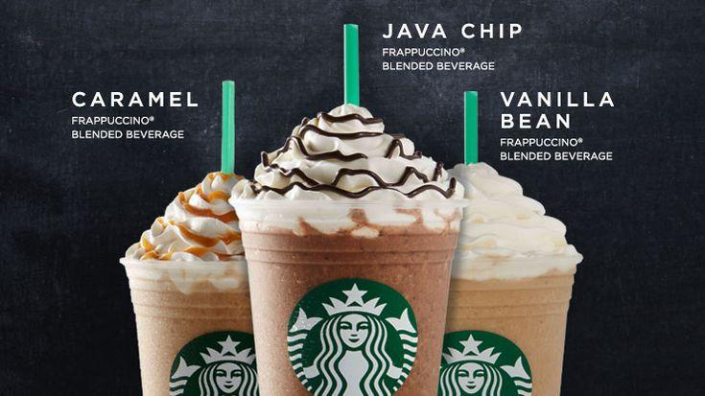
02 — ICED COFFEE

Item |  |  |  |  | Price
Iced Americano |  |  |  |  | ₹270
Iced Latte |  |  |  |  | ₹320
Iced Mocha |  |  |  |  | ₹370
Iced Caramel Macchiato |  |  |  |  | ₹390
Cold Brew |  |  |  |  | ₹350

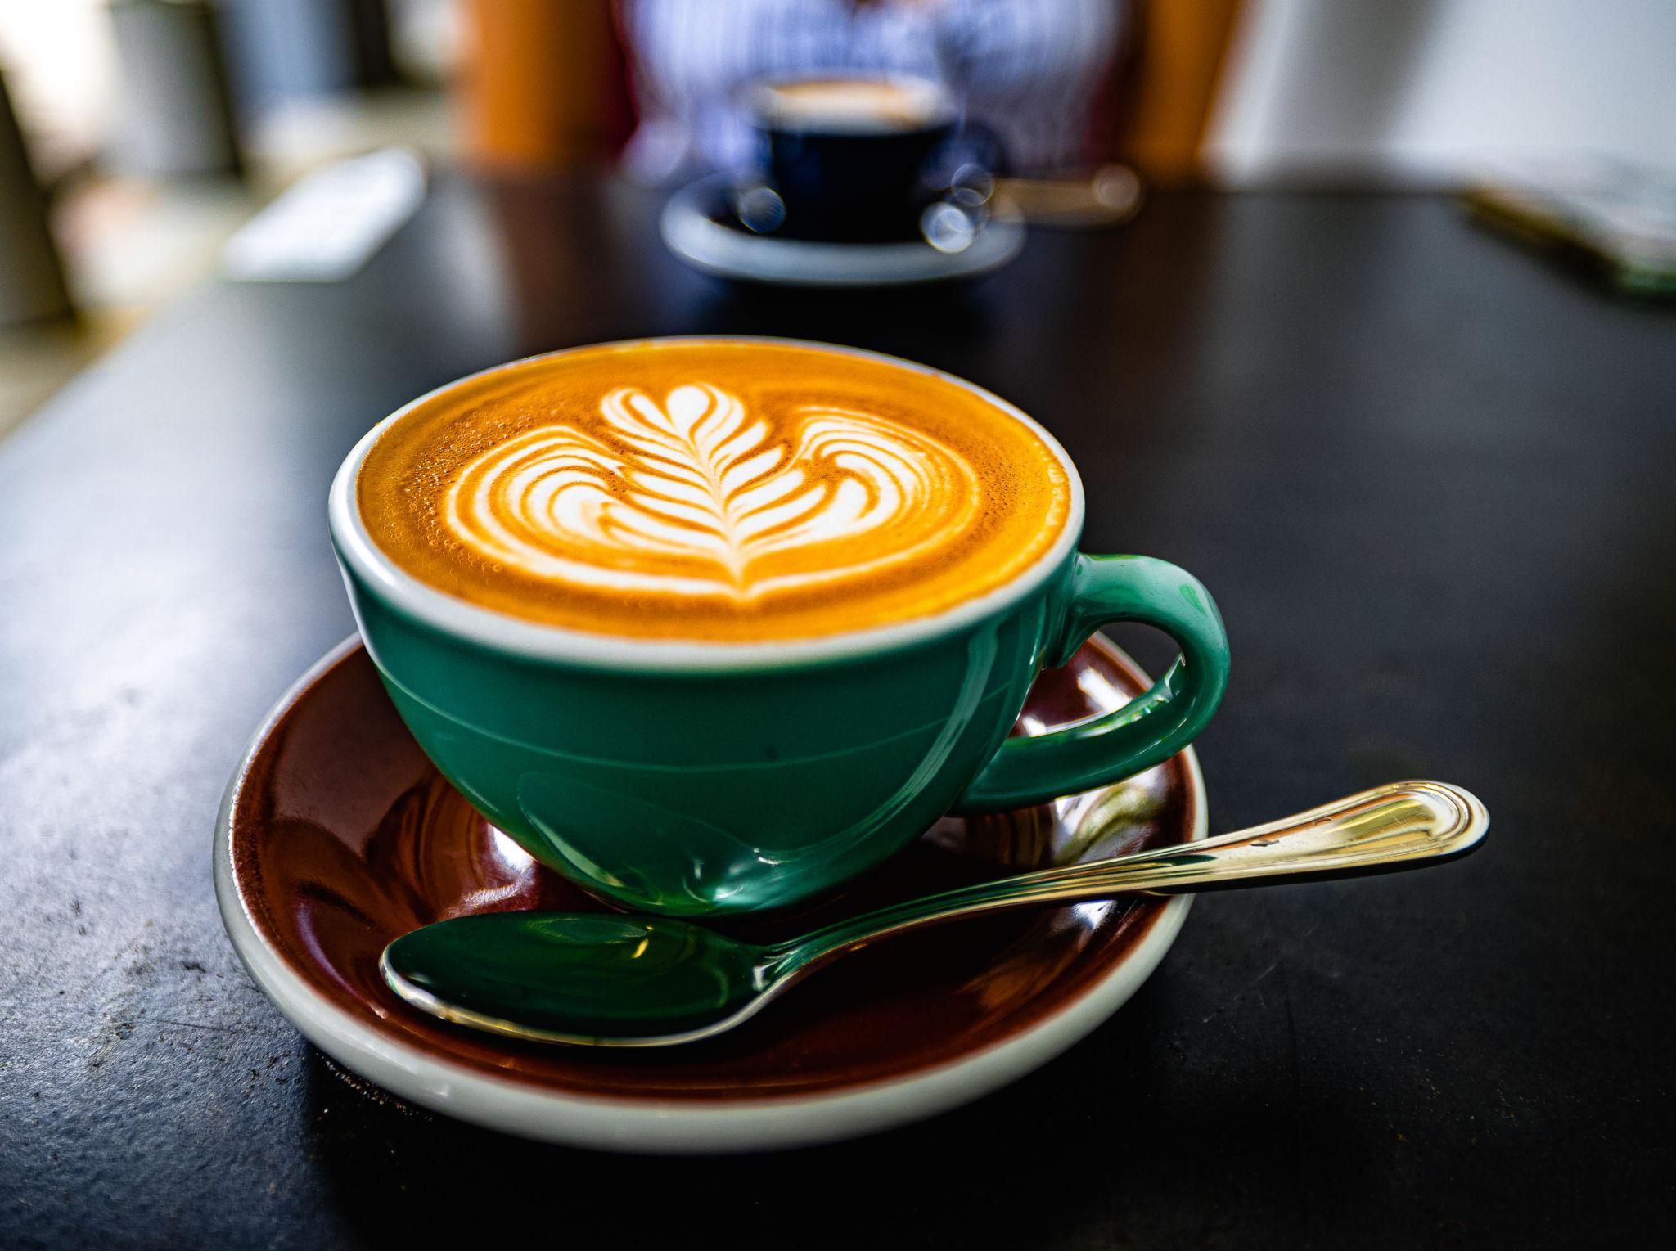
Item |  |  |  |  |  |  |  |  |  | Price
Espresso |  |  |  |  |  |  |  |  |  | ₹220
Americano |  |  |  |  |  |  |  |  |  | ₹250
Cappuccino |  |  |  |  |  |  |  |  |  | ₹310
Caffè Latte |  |  |  |  |  |  |  |  |  | ₹320
Caffè Mocha |  |  |  |  |  |  |  |  |  | ₹360
Caramel Macchiato |  |  |  |  |  |  |  |  |  | ₹380
Vanilla Latte |  |  |  |  |  |  |  |  |  | ₹360

01 — ESPRESSO & HOT COFFEE

